Jennifer Stegina

22 September 2019

CIS 250

**Unit 5 Guided Practice 1**

The following questions come from the Task examples of Chapter 15 in your textbook.

After you are finished, please submit a Microsoft Word file that contains screenshots the SQL queries, the output, and please put a comment line in each query with your name. Your document should be named **U5_GuidedPractice1_Lastname.docx**.

(15-2) Question 1:

Show an example of a *union all*.

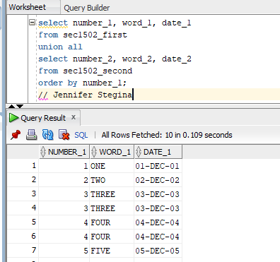

(15-3) Question 2:

From the *l_lunches* table, count the number of lunches each employee will attend. Get the last name and first name of each employee from the *l_employees* table using an inner join. Do not try to include employees who are not attending any lunches. Use a *union* to include a row showing that you will not attend any of the lunches.

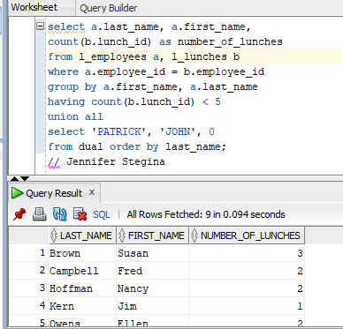

(15-4) Question 3:

Show a *union* that uses a column name in its *order by* clause.

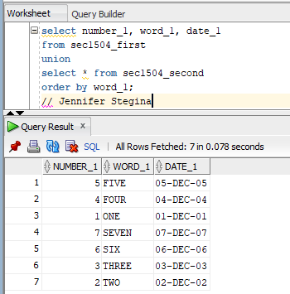

(15-4) Question 4:

Show a *union* that uses a column position number in its *order by* clause.

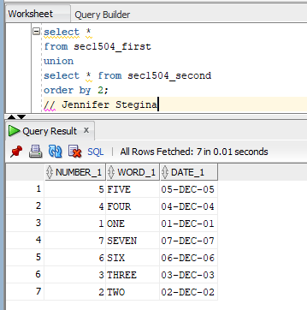

(15-5) Question 5:

Create a view in Oracle that is defined using a *union*. Show that you can also include an *order* by clause.

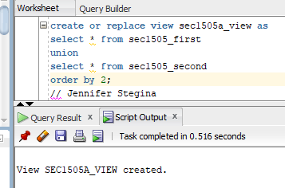

(15-5) Question 6:

Create a table in Oracle that is defined using a *union*. Show that you can also include an *order* by clause.

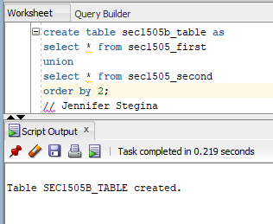

(15-7) Question 7:

Show how to use datatype conversion functions in a union to make every column into a text column.

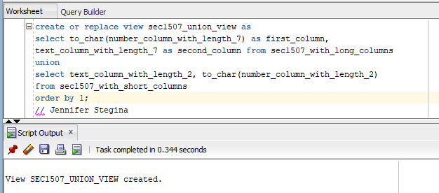

(15-8) Question 8:

Show how to form a union of two tables that have different numbers of columns.

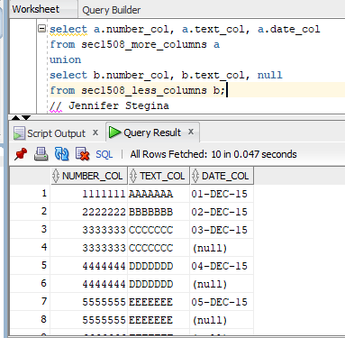

(15-9) Question 9:

Test whether two tables are identical. We already know that these tables have the same number of columns and that the datatypes of those columns are compatible.



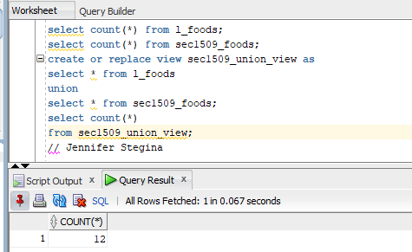

(15-10) Question 10:

Show a *select* statement that uses a *union* with literals to identify the source of each row.

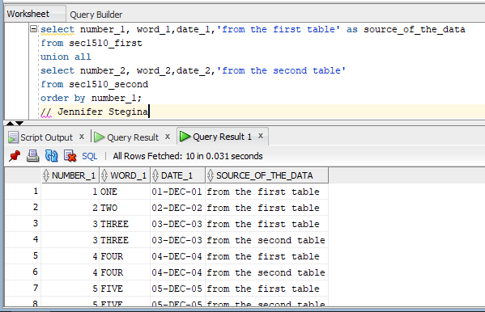

(15-11) Question 11:

List the foods and their prices. Add the message “expensive item” to the foods that cost more than $2.00. List the foods in alphabetical order.

